Mid-term Test Modules 1- 4

VOCABULARY

A. Cross out the odd word.

1. French Turkey Chinese Brazilian
2. camera shoes suit trousers
3. theatre museum passport bank
4. cooker cupboard fridge microwave
5. architect doctor chef colleague
6. sink shower desk toilet
6

score
B. Match.

1. mobile
2. police
3. remote
4. soap
5. living
6. ground

a. officer
b. floor
c. phone
d. room
e. control
f. opera
6

score

C. Complete with the words in the box.

shower view rubbish garden centre motorbike

1. The from my bedroom is fantastic.
2. Victor rides a to work.
3. Jennifer has a every morning.
4. Please, take out the .
5. There’s a lovely behind the house.
6. Frank lives in the city .
6

score

COMMUNICATION
Choose a or b.

1. A: How’s it going?
B:
a. I take the bus.
b. Not bad.

2. A: Have you got any brothers or sisters?
B:
a. No, I’m an only child.
b. No, I’m not.

3. A: How do you get to work?
B:
a. I give my sister a lift.
b. I use the underground.

4. A: What’s your address?
B:
a. On Wilkinson Road.
b. 17 Terryville Road.

5. A: What time do you start work?
B:
- On Mondays, Wednesdays and Fridays.
b. At 8 o’clock.

6. A: What do you do?
B:
a. I’m a musician.
b. I’m fine thanks.
6

score

GRAMMAR
A. Complete with Whose, Who, What, When, How or Where.

1. A: old is David?
B: He’s seventeen years old.

2. A: is the bank?
B: It’s opposite the police station.

3. A: is this jacket?
B: I think it’s Debbie’s.

4. A: do you go to the gym?
B: On Mondays and Wednesdays.

5. A: is that girl over there?
B: Oh, that’s Linda.

6. A: do you usually do in the evening?
B: I hang out with my family.
6

score

B. Complete with the correct form of the verb have got.

1. A: Karen long fair hair?
B: She long hair but she fair hair. Her hair
is brown.
2. A: they any children?
B: Yes, they have. They two sons.
A: What about a daughter?
B: No, they a daughter.
6

score

C. Complete with the Present Simple of the verbs in brackets.
1. A: the boys (play) basketball on
Tuesday afternoons?
B: No. Jeffrey (play) tennis and Paul
(sometimes / go) jogging then.
2. Kathy (not iron) but she (always / do)
the washing.
3. A: Samantha (use) the underground
every day?
B: No, she (usually / take) the bus.
4. My wife and I (not watch) reality shows.
5. A: you (listen) to the radio in your car?
B: Yes, I do.
6. I (get) home late on Fridays.
10

score

D. Choose a, b or c.

1. What do you do the weekend?
a. for b. at c. in

2. Susan is famous actress.
a. the b. a c. an

3. Mandy’s got a brother. name is Carl.
a. His b. Him c. He’s

4. Ray’s got a cat. black and white.
a. It b. Its c. It’s

5. There are two lamps in my bedroom. red lamp is on my desk.
a. The b. A c. This

6. The rug is of my bed.
a. next b. in front c. under

7. I never watch chat shows. I hate .
a. it b. their c. them

8. This isn’t my jacket. is my jacket over there.
a. That b. This c. These
8

score

LISTEN
Listen to three dialogues and choose a or b.

1. The basketball game starts at:
a.  b. 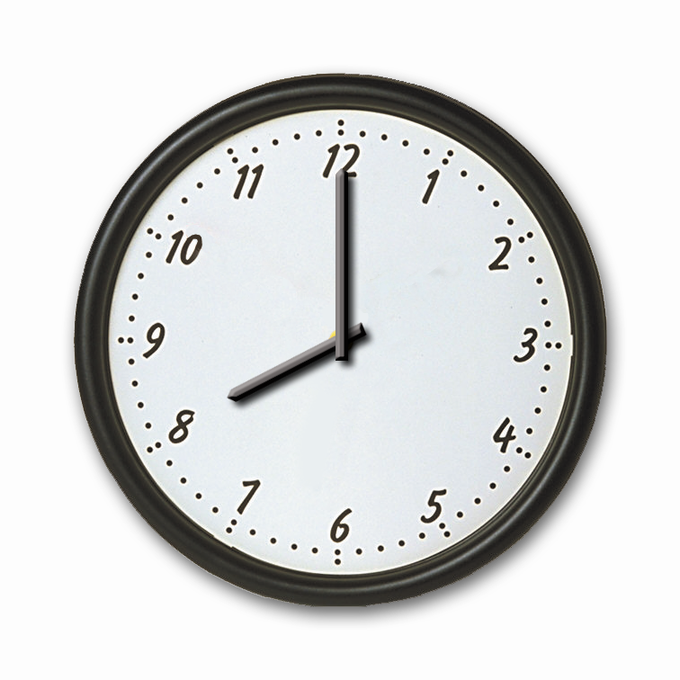

2. Charlie’s sister:
a.  b. 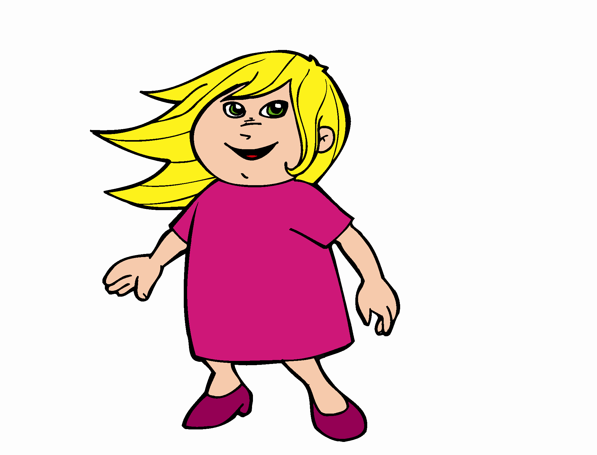

3. Debbie’s flat
a. 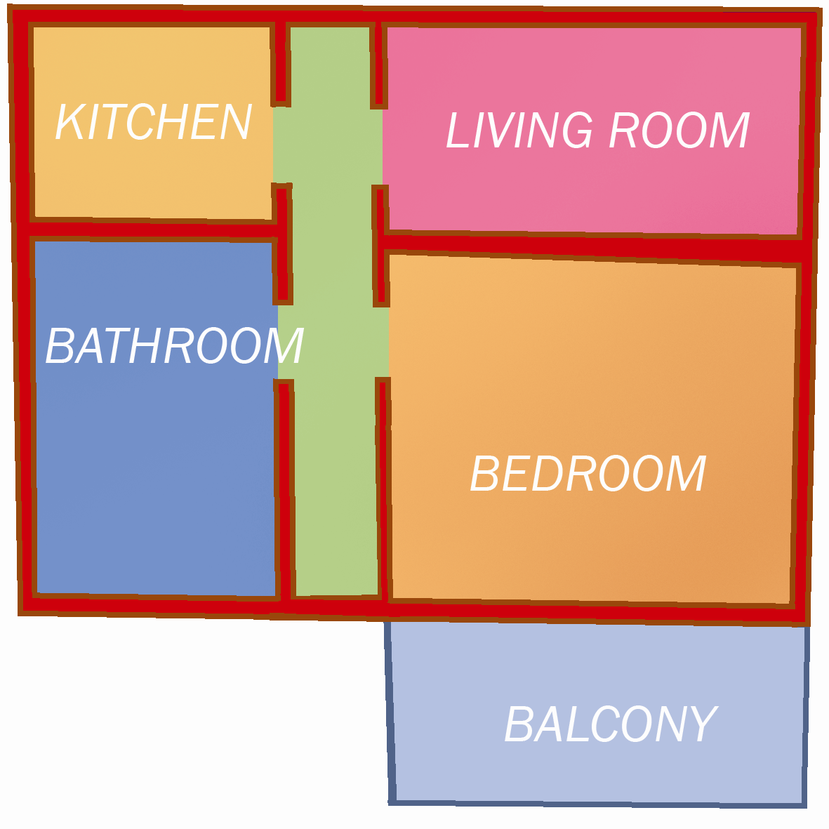 b. 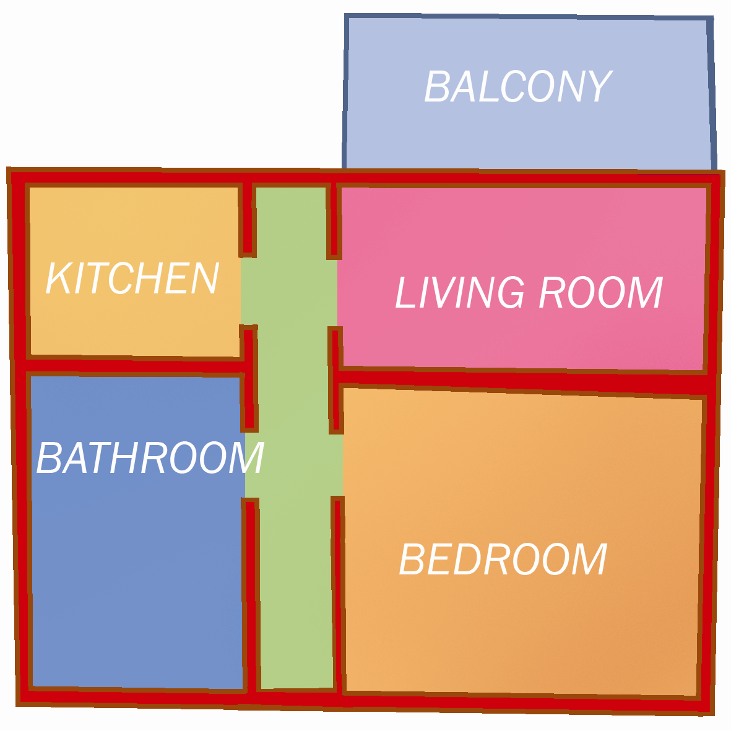

6
score

READ
Read and write T for True or F for False.

My name is Darcy Smith and I am 20 years old. I live with my flatmate Sally and our dog, Rex. Sally and I are good friends but I have a problem with her. Sally thinks she does all the housework but she’s wrong! I do the washing-up every night after dinner. I hoover the living room and do the washing every Wednesday. I also take the dog for a walk every day. Sally never does that! On Saturdays Sally and I usually tidy the house. Sally sometimes irons her clothes but she never irons my clothes!

1. Darcy and Sally have a cat named Rex.
2. Sally thinks Darcy does all the housework.
3. Darcy walks Rex every day.
4. Darcy hoovers the living room every night.
5. Darcy and Sally tidy the house at the weekends.
10

score

WRITE
Write a paragraph about yourself. Answer the questions below:
What’s your name?
Where are you from?
How old are you?
What do you do?
What do you look like?
What do you do in your free time?

10

score

80

Total score

